**Topic-1 Create service using docker stack**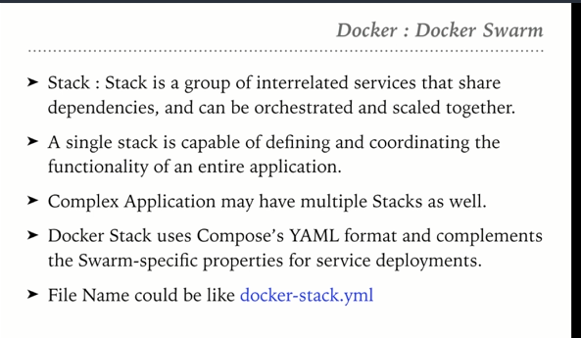

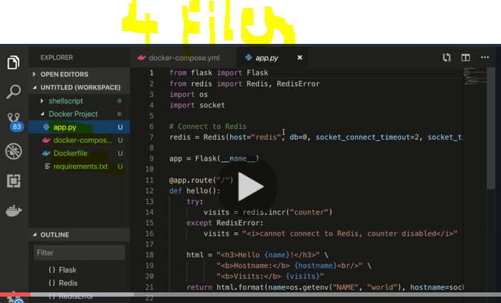

Docker file which references the app.py application

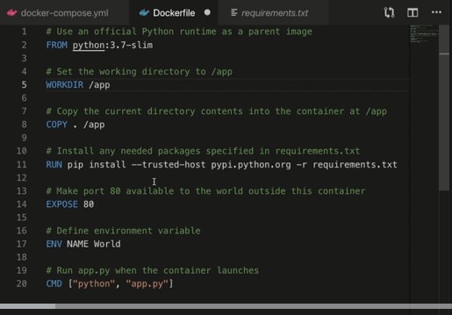

Pull the image from hub.docker.com by mentioning it under the Image tag in the docker-compose file (Eg: image : 52050430/friendlyhello:latest)

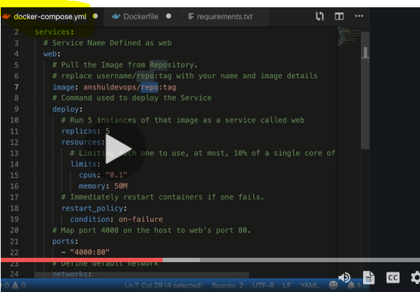

**Explanation of Docker-compose.yml file**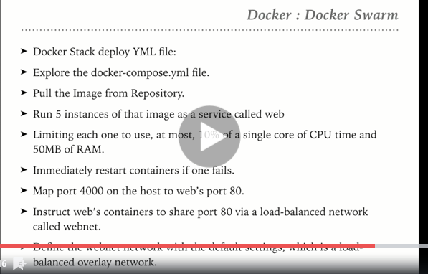

**How to deploy service using docker stack**

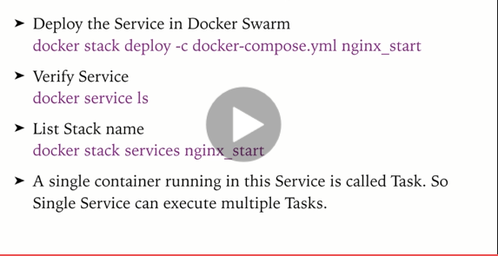

How to verify the services 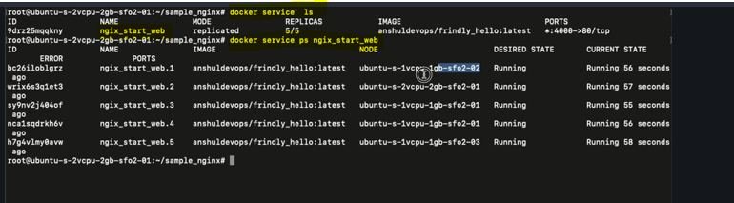

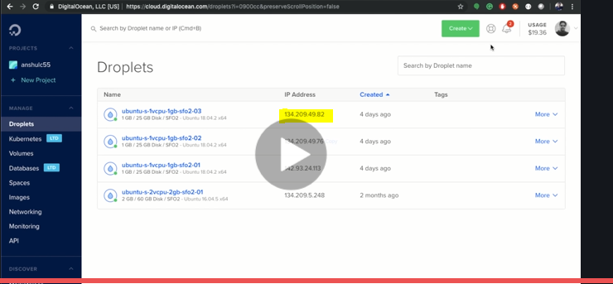

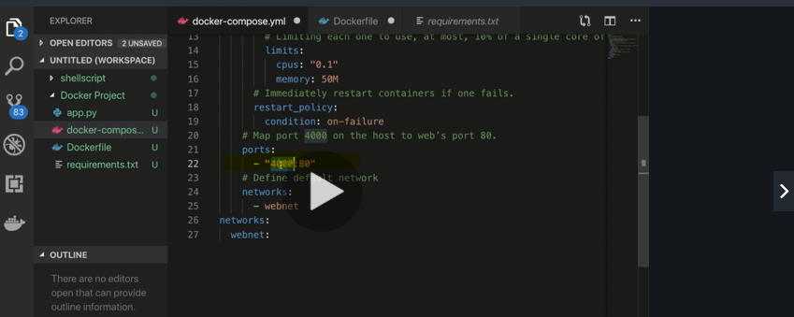

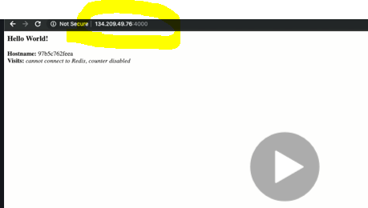s

**Topic-2: Scaling services**

**Existing service scheduled on 5 replicas**

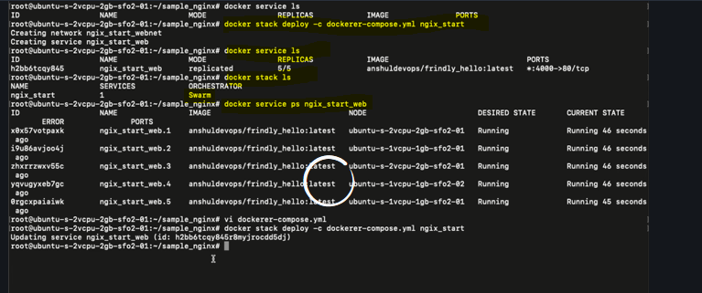

Change the configuration in the docker-compose yml file to change the configuration like Memory, CPU utilization and increase to 6 replicas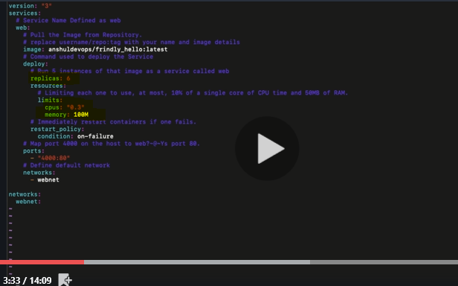

Deploy the service again to see that the new configurations are taken into account

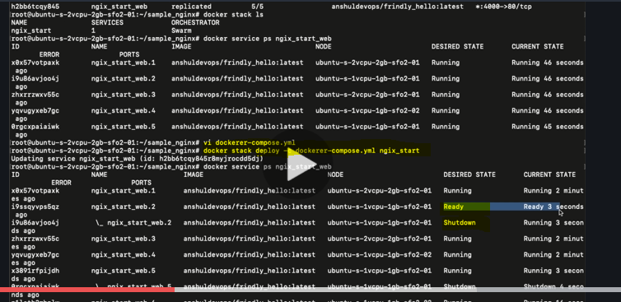

Note: The old containers are stopped and new containers are started with new configuration without any downtime

After some time if we check the running services using

Docker service ps nginx_start_web, we get the below output where we can see that, there 5 containers which are stopped (as they were with old configuration) and there are 6 containers in “Running” state with the new configuration.

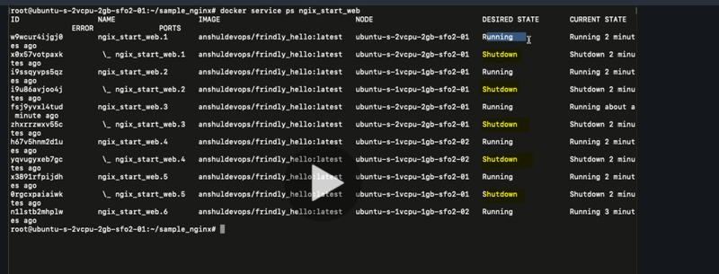

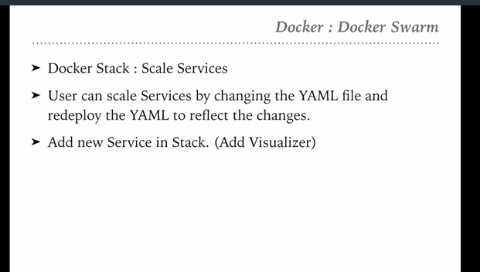

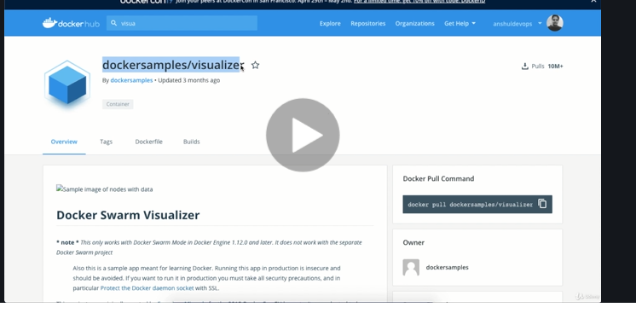

Modify the docker-compose.yml file to include the visualiser service

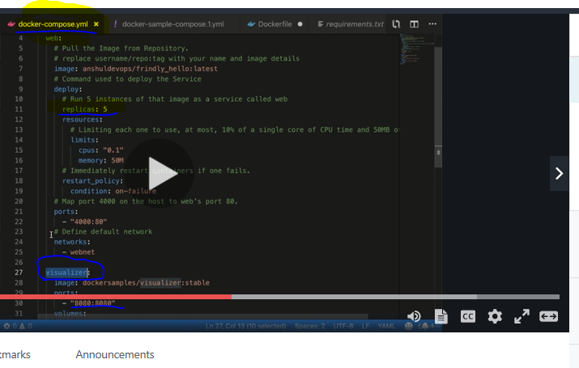

Mention that the viusalizer service should run only on the Manager/Leader node in the swarm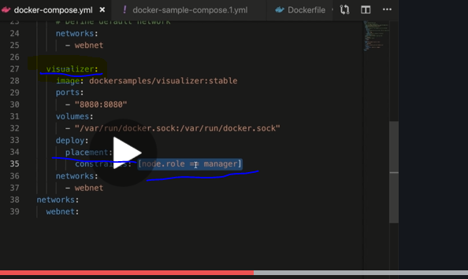

Visualizer service will be started

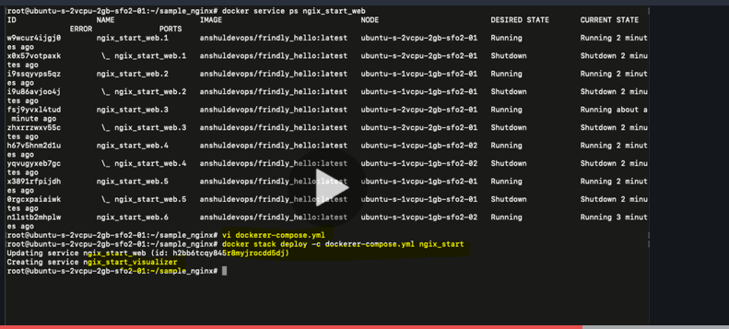

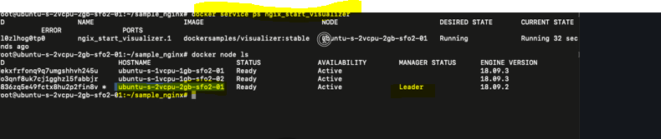

Select any node 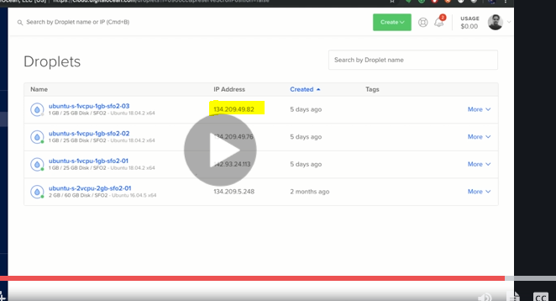

Invoke with port 8080 where visualiser is exposed. You will get to see the running containers on each node. Visualiser itself is a service runnong on the Leader node

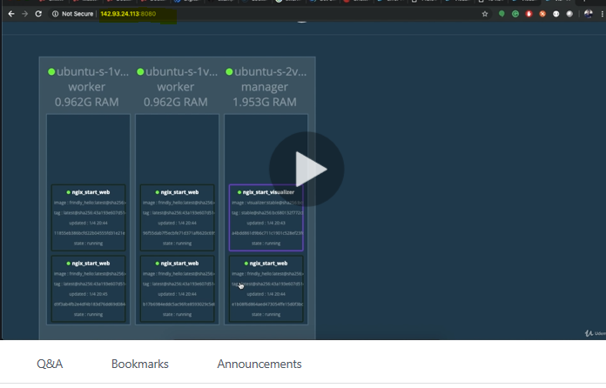

**Topic-3: How to solve persistent data problem in swarm**

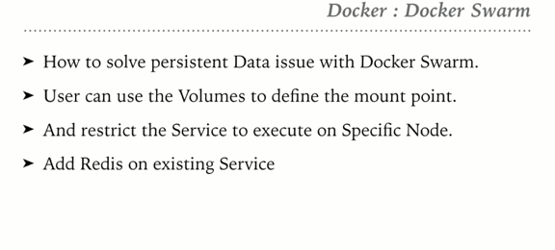

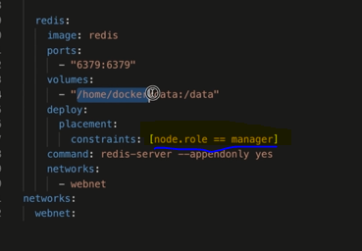

Change the mount location to use the data directory which is present inside the working directory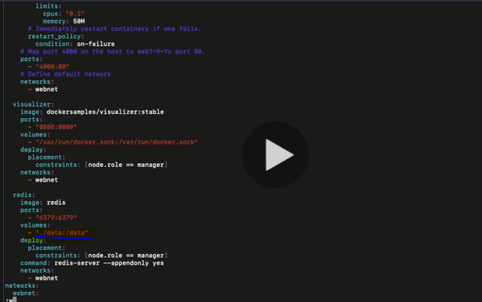

Create a new directory called data and then deploy the service

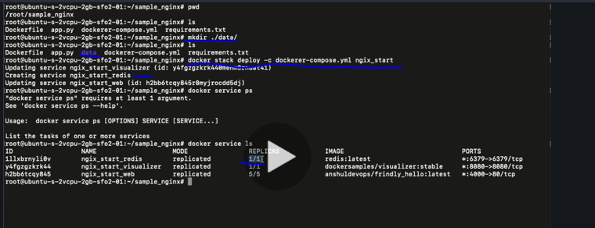

**Topic-4: Deploy distributed application**

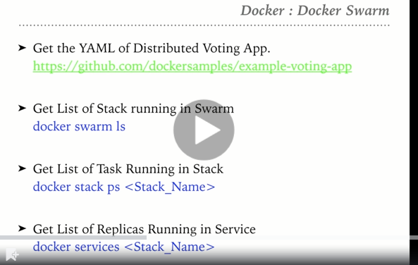

**Create a docker-stack.yml file**

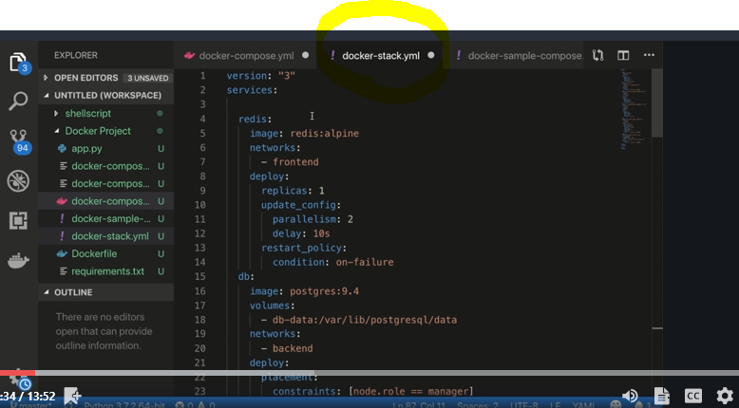

Create a new file name called docker-stack.yml and copy the content from the docker-stack.yml created in VisualStudio code.

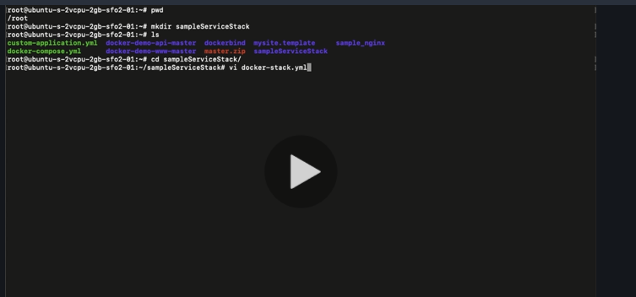

**To deploy an application using stack:**

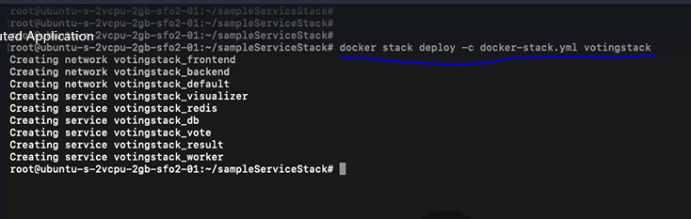

**How to check number of stack and services running inside the stack:**

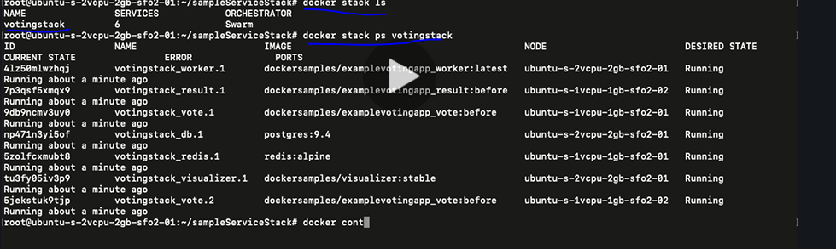

**How to check number of services and their replicas**

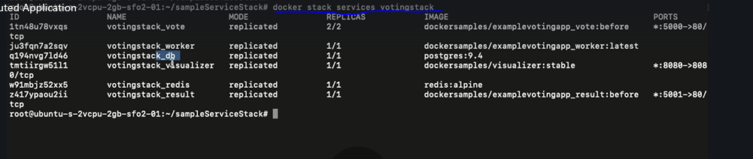

**Worker service may give the below exception:**

